SCHOOL OF COMPUTER SCIENCE AND ARTIFICIAL
INTELLIGENCE
- Sentiment Classification for Customer Reviews
Scenario:
Prompt:
✅ Zero-shot Prompt
Classify the sentiment of the following customer review as Positive, Negative, or Neutral.
Review: “The product quality is excellent.”
✅ One-shot Prompt
Example:
Review: “Worst product ever”
Sentiment: Negative
Now classify the sentiment of the following review:
Review: “The product quality is excellent.”
✅ Few-shot Prompt
Review: “Amazing quality and fast delivery” → Positive
Review: “Very disappointing experience” → Negative
Review: “Product is okay, nothing special” → Neutral
Classify the sentiment of the following review:
Review: “The product quality is excellent.”
the code:
reviews = [
"The product quality is excellent",
"Worst purchase ever",
"It is okay, not great",
"Very happy with the service",
"The item arrived broken",
"Delivery was on time"
]

def sentiment_classifier(review):
if any(word in review.lower() for word in ["excellent", "happy", "great"]):
return "Positive"
elif any(word in review.lower() for word in ["worst", "broken", "bad"]):
return "Negative"
else:
return "Neutral"

for r in reviews:
print(r, "->", sentiment_classifier(r))
screenshots from the compiler
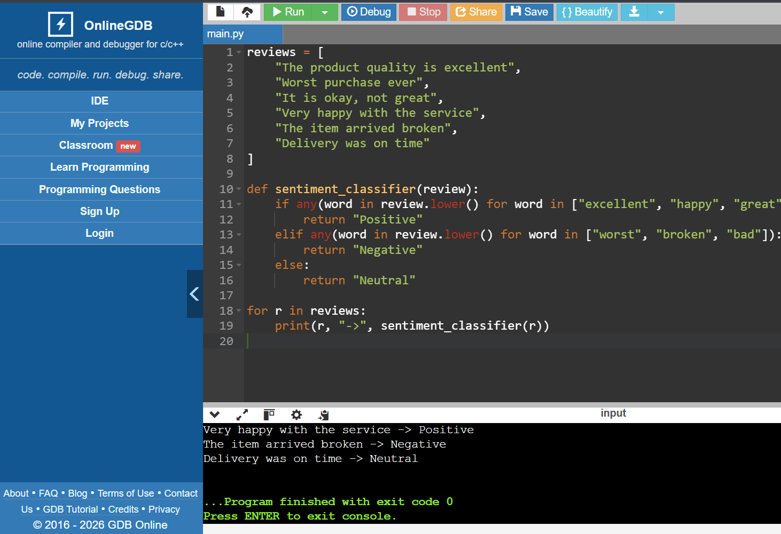
- Email Priority Classification
Scenario:
The prompt
✅ Zero-shot Prompt
Classify the following email into High, Medium, or Low priority.
Email: “Server is down, urgent fix needed.”
✅ One-shot Prompt
Example:
Email: “Client complaint regarding service”
Priority: High
Now classify the priority of the following email:
Email: “Server is down, urgent fix needed.”
✅ Few-shot Prompt
Email: “System failure detected” → High
Email: “Project update submission” → Medium
Email: “Team lunch invitation” → Low
Classify the priority of the following email:
Email: “Server is down, urgent fix needed.”
The screen shots from compiler
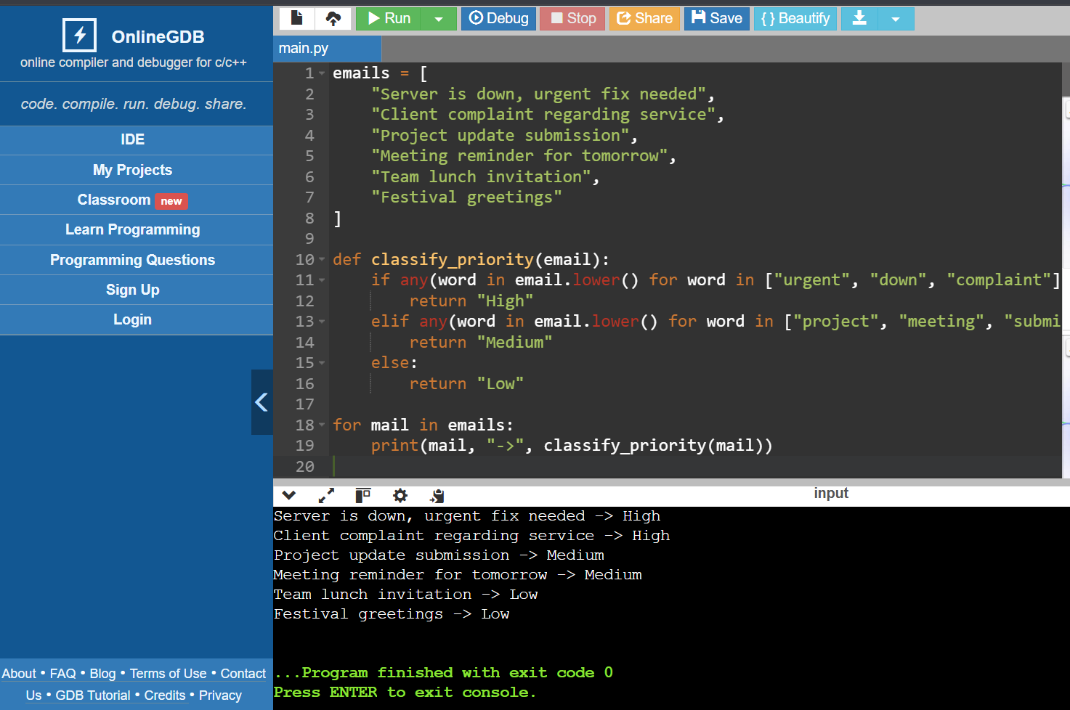

- Student Query Routing System
Prompt:
✅ Zero-shot Prompt
Route the following student query to one of these departments:
Admissions, Exams, Academics, Placements.
Query: “How can I apply for admission?”
✅ One-shot Prompt
Example:
Query: “Exam timetable release date?”
Department: Exams
Now route the following query:
Query: “How can I apply for admission?”
✅ Few-shot Prompt
Query: “Syllabus for AI subject” → Academics
Query: “Placement drive details” → Placements
Query: “Revaluation process” → Exams
Route the following query:
Query: “How can I apply for admission?”
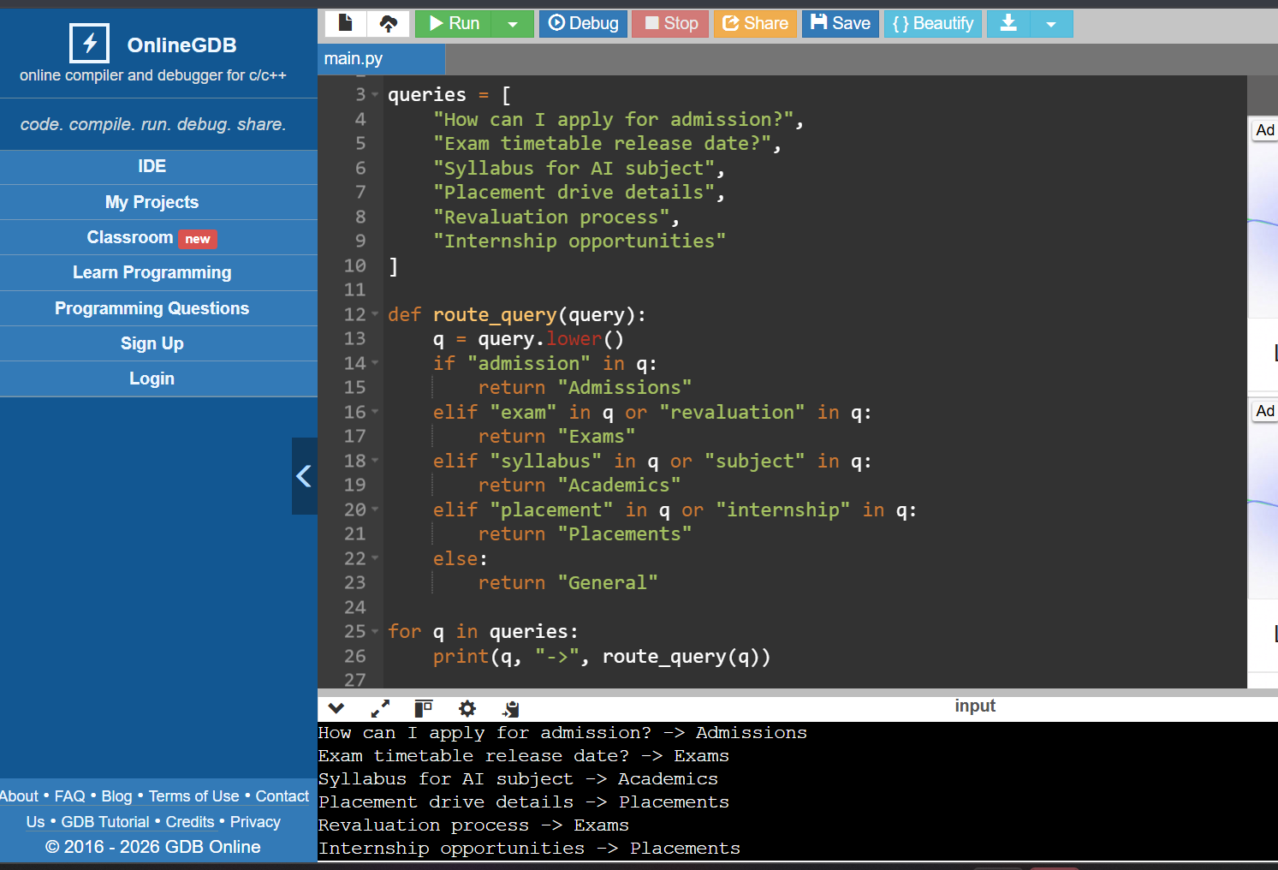

4. Chatbot Question Type Detection
Prompt
✅ Zero-shot Prompt
Identify the question type of the following chatbot query as
Informational, Transactional, Complaint, or Feedback.
Query: “What is the exam date?”
✅ One-shot Prompt
Example:
Query: “Pay my exam fee”
Type: Transactional
Now classify the type of the following query:
Query: “What is the exam date?”
✅ Few-shot Prompt
Query: “How to reset password?” → Informational
Query: “Website is not working” → Complaint
Query: “Great support service” → Feedback
Classify the following query:
Query: “What is the exam date?”
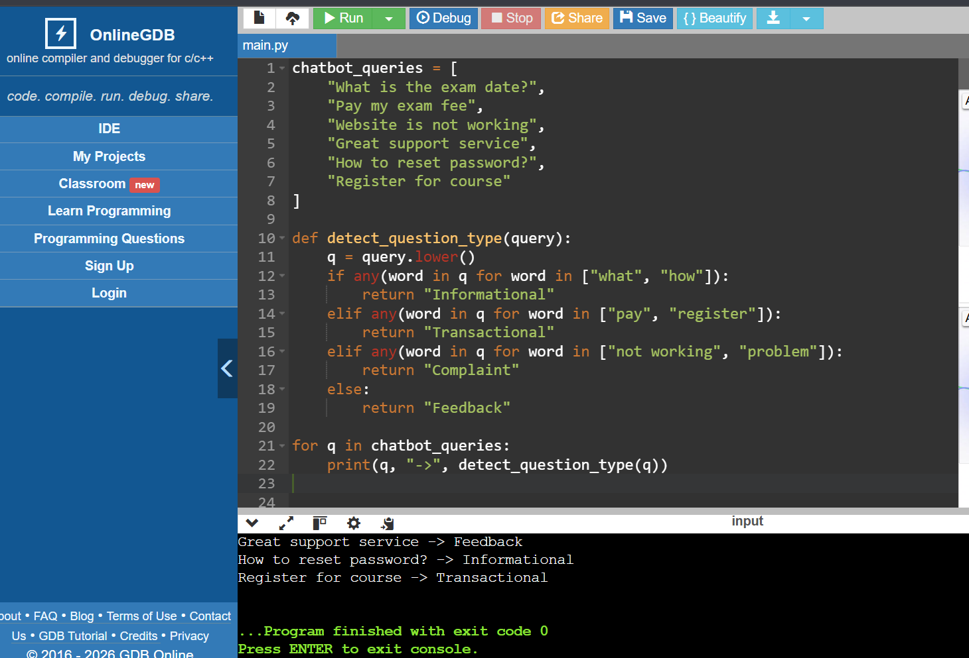
5. Emotion Detection in Text
Prompt
✅ Zero-shot Prompt
Identify the emotion expressed in the following text as
Happy, Sad, Angry, Anxious, or Neutral.
Text: “I am worried about exams.”
✅ One-shot Prompt
Example:
Text: “I am very happy today”
Emotion: Happy
Now identify the emotion in the following text:
Text: “I am worried about exams.”
✅ Few-shot Prompt
Text: “Feeling excited and joyful” → Happy
Text: “This makes me angry” → Angry
Text: “It’s a normal day” → Neutral
Identify the emotion in the following text:
Text: “I am worried about exams.”

Screenshot from compiler
